**FDIC (Federal Deposit Insurance Corporation)**

The Federal Deposit Insurance Corporation (FDIC) is an independent federal agency that insures deposits in U.S. banks and thrifts against bank failures. The FDIC's primary objective is to instill public confidence in the financial system and promote sound banking practices

**Financial Statements:** The FDIC's financial statements for the Deposit Insurance Fund (DIF) and the Federal Savings and Loan Insurance Corporation (FSLIC) Resolution Fund (FRF) for the years ended December 31, 2023, and 2022, were presented fairly in accordance with U.S. generally accepted accounting principles (GAAP).

**Internal Controls:** The FDIC maintained effective internal controls over financial reporting relevant to the DIF and FRF as of December 31, 2023.

**Noncompliance:** There were no reportable instances of noncompliance with tested provisions of applicable laws, regulations, contracts, and grant agreements for 2023.

**Progress on Deficiencies:** The FDIC made significant progress in addressing a significant deficiency in contract documentation and payment review process controls, which GAO reported in its prior year audits.

**FDIC Coverage and Role**

**Deposit Insurance:** The FDIC insures deposits up to $250,000 per depositor, per account ownership category, including checking and savings accounts, certificates of deposit (CDs), money market accounts, individual retirement accounts (IRAs), revocable and irrevocable trust accounts, and employee benefit plans.

**Bank Failures:** The FDIC safeguards deposits in American banks and thrifts during instances of bank failures, providing a safety net for depositors and allowing banks to address financial issues under controlled circumstances.

**Preventing Panic:** The FDIC was established to prevent "run-on-the-bank" scenarios and restore consumer confidence in the financial system, which was a major issue during the Great Depression.

**Research and Analysis**

**Center for Financial Research:** The FDIC's Center for Financial Research promotes research on topics important to the FDIC mission, including deposit insurance, bank supervision, and resolution of failed financial institutions.

**Quarterly Banking Profile:** The FDIC publishes a comprehensive summary of financial results for all FDIC-insured institutions, providing insights into the industry's performance and trends.

**Bank Data & Statistics:** The FDIC provides various databases and reports for accessing financial and demographic data on specific banks and the industry as a whole.

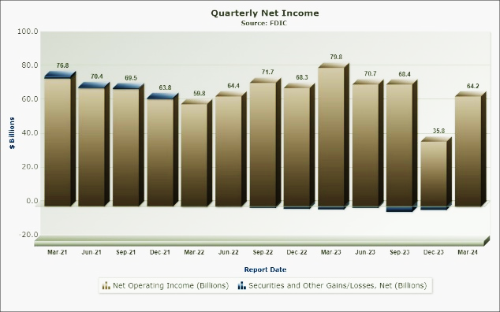

The FDIC plays a crucial role in maintaining stability in the U.S. financial system by insuring deposits in banks and thrifts against bank failures. Its analysis reports provide valuable insights into the industry's performance, trends, and regulatory requirements, helping to promote sound banking practices and public confidence in the financial system.

**The FDIC made several updates to its crisis planning in 2023:**

**Development of a Financial Crisis Readiness Plan:** The FDIC was recommended to develop a financial crisis readiness plan that includes a scenario involving the resolution of multiple concurrent failures of systemically important financial companies. This plan would help ensure the FDIC's operational readiness to administer the resolution of large, complex financial institutions and support the stability of the U.S. and global financial systems.

**Enhancing Crisis Readiness and Response Planning:** The FDIC's crisis readiness and response planning were identified as areas for improvement. The agency needs to mature its Orderly Liquidation Authority (OLA) program by implementing the recommendations in the report, which includes developing a financial crisis readiness plan and enhancing OLA resources, training, and exercises to plan for and execute an OLA resolution.

**Improving OLA Resources and Training:** The FDIC needs to enhance OLA resources, training, and exercises to plan for and execute an OLA resolution. This includes ensuring that the agency has the necessary resources and personnel to effectively manage the resolution of large, complex financial institutions.

**Enhancing Monitoring Mechanisms:** The FDIC should establish adequate monitoring mechanisms to ensure it promptly implements the OLA program and consistently measures, monitors, and reports on the OLA program status and results.

**Addressing Deficiencies in Contract Documentation and Payment Review Process Controls:** The FDIC identified deficiencies in contract documentation and payment review process controls and has proposed corrective actions to address these issues by December 31, 2025.

These updates aim to improve the FDIC's preparedness for crises and ensure the stability of the financial system by enhancing its crisis planning, resources, and monitoring mechanisms.

**Inference:**

* **Insures deposits:** Protects your money in banks and thrifts (up to $250,000) in case of a bank failure.
* **Maintains financial stability:** Promotes public confidence in the banking system by preventing bank runs and failures.
* **Provides valuable data:** Offers research and analysis on industry performance and trends.
* **Enhances crisis preparedness:** Working to improve its ability to handle large failing banks through planning, resources, and monitoring.
* **Addressing internal controls:** Fixing weaknesses in contract documentation and payment review processes.